FD-S Series Ducted Dehumidifier
Model:FD-S100L
Dehumidifying Capacity: 100L/D

PHOTO

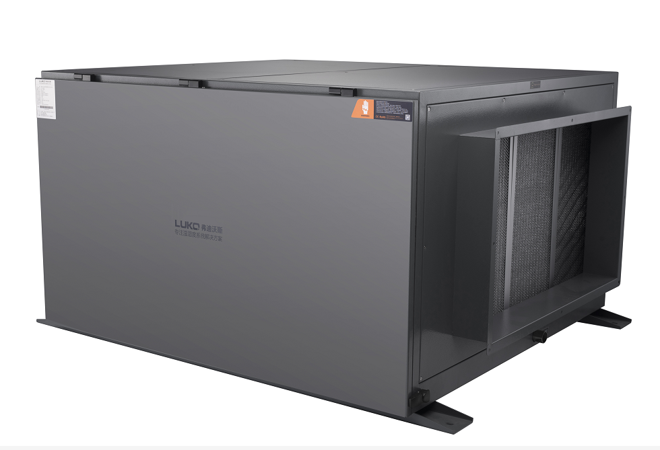

FD-S Series Ducted Dehumidifier
WORKING PRINCIPLE
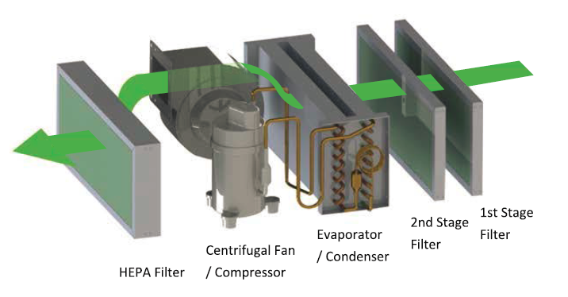
FD-S series is the company's self-developed recirculated air dehumidification system. The system will first capture the indoor air to pass through the first stage (G4 efficiency) and second stage (F5 efficiency) air filtration in order to remove air borne particles and contaminants. The partial filtered air will then enter into the direct expansion dehumidification system to remove the excess moisture. The excess moisture in the air will be condensate and turn into water. The water will then be collected at a drain pan, where it will be pushed out with the help of positive air pressure from the processed air. The dried air will then pass through the final stage of HEPA filter to remove micron size particles and airborne bacteria. The final output air will be cleaned and dried. The same process will continue to work until the ambient air reach to the set-point of the desire humidity level.
This system is suitable for area that are enclose and not require to introduce fresh air, for example like warehouse, storage and equipment room that require to keep the room constantly dry at all times.
With LUKO FD-S system, the recirculated air dehumidification system would help to constantly keep the treated room dry without loss of energy, as the dry air is contain within the room. Hence, this would help to constantly maintain the humidity level without affecting the stored goods or production process that are highly sensitive to moisture.

FD-S Series Ducted Dehumidifier

KEY FEATURES

*The body material is made of cold-rolled sheet metal with epoxy powder coating
*A mini measuring level sticked on the bottom side of the unit, which can help to keep the balance during installation
*An electric heater can be mounted in the air outlet duct for further heating of the dry air
*Built-in Centralized Fresh Air Fan with self-balancing function to exhaust excessive moisture from the indoor ambient air
*Condensate trap does not need to install because of the positive pressure drainage design.This helps to save more space during installation.
*Evaporator and Condenser is epoxy-coated for better durability and corrosion resistant. It is also washable for maintenance service.
*The machine is built for 24/7 operation with automatic dehumidification and positive pressure drainage
*Low Noise, High Static Pressure, Double Speed Centrifugal Fan, which allow fan speed adjustment.
*Blue hydrophilic-coated aluminum-fin heat exchanger coils and SS304 condensate drain pan is made of prevent corrosion damage;
*Purifying spare parts replacement is mandatory,which can better improve the air quality and the machine’s service life.
*Air Purifying section can be integrated freely into the system(Medium Efficiency Filter, HEPA Filter, Activated Carbon Filter, UV Sterilizing Lamp and Negative Ionizer).
*The machine uses name-brand compressor Panasonic or Embraco,with eco-friendly R410A or R134A refrigerant.
*The hinged side panel design ensure easy access to the internals for the maintenance.
*The machine can be connected and monitored with RS485 interface and Wi-Fi App.
*Touch screen controller (integrated with temperature & humidity sensor) simplifies complex wiring and installation.

FD-S Series Ducted Dehumidifier

COMPARISON WITH SIMILAR PRODUCTS(please contact us for more information)
 | Other brands | LUKO
Positive pressure design | NO | YES for the models capacity below 240L/D
circuit board | YES | Built in the controller
humidity sensor | Installed at the return air duct | Built in the controller
controller | simple humditity controller | Circuit board + temp & humidity sensor + precision controller built in one package
APP | NO | YES
RS485 port | NO | YES
compressor | Panasonic or other brand | Imported Embraco made in Brazil for the smaller models,Panasonic for the medium models and Daikin for the big ones
fan | self-assembled fan for big models | all tested and ordered from brand-name fan suppliers
heat exchanger | galvanized steel | SS304 end plate
heat exchanger copper coil thickness | 0.32MM | 0.5MM
copper tube thickness | 0.5/0.75MM | 0.75 /1.0MM
filter | 1 filter | S series:G4+UV light+Anion
 |  | X series:G4+F7+H13+UV light+Anion
filter change alarm | NO | YES
compressor capacity | smaller capacity for big units | enough capacity for big units

FD-S Series Ducted Dehumidifier

CONTROL

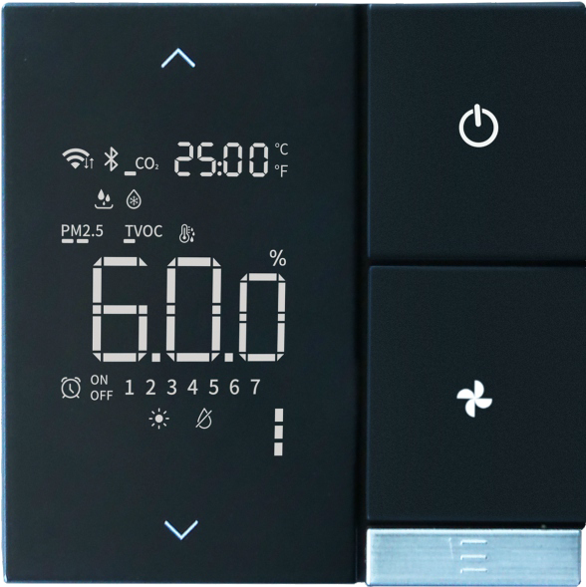

FD-S Series Ducted Dehumidifier

TECHNICAL DATAS
Technical Data
MODEL | FD-S100L
Capacity(30℃,80%RH) | 100L/D
Supply air flow(m3/h) | 1000-1200
Fan speed | 2-speed/variable speed
Static pressure | 100 Pa
Return air flow(m3/h) | 1000-1200
Power | 920 W
Current | 4.3A
Voltage | 220V/50Hz
Control | *Built-in humidity & temp. sensor; *RS485,APP available
Noise level | <45DB
Compressor | Panasonic
Refrigerant | R410A
Condenser | copper tubes with blue hydrophilic-coated aluminum fins
Drain pan | SUS304
Drain hole size | DN20
FIlter | G4
Purification | UV Air Sanitizer + Anion Generator
Return air duct | Φ200 mm
Supply air duct | Φ200 mm
Net weight | 68kg
Unit price(FOB Shanghai) | US$910
*Technical Specifications and dimensions are subject to change without prior notice
FD-S Series Ducted Dehumidifier

DIMENSION

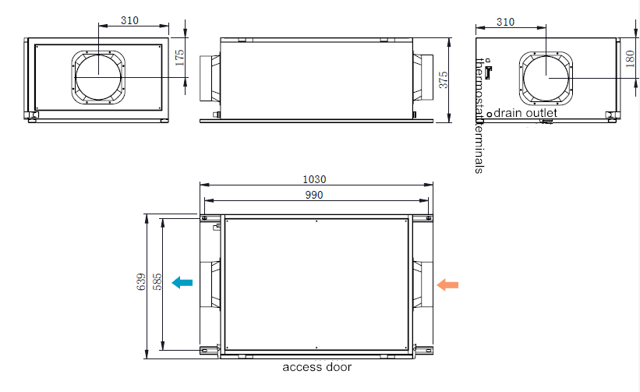

FD-S Series Ducted Dehumidifier

PERFORMANCE

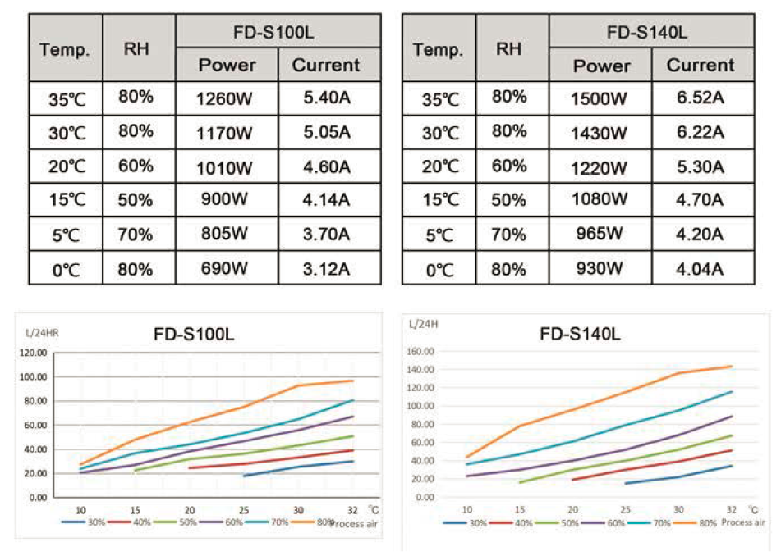

FD-S Series Ducted Dehumidifier

INSTALLATION
